RENEWSEC 2025 website changes

About RENEWSEC 2025 contact change to this

As India accelerates its transition towards a sustainable future, its renewable energy (RE) sector has witnessed unprecedented growth. In 2024, the country made significant strides in solar and wind energy installations, policy advancements, and infrastructural improvements, setting the stage for ambitious targets in 2025. With a commitment to achieving 500 GW of non-fossil fuel-based energy capacity by 2030, India is emerging as a global leader in clean energy.

As the renewable energy sector rapidly scales up across solar, wind, hydro, green hydrogen, and storage, the need for strong cybersecurity and OT protection has never been more critical. Keeping in mind the above scenario, we are pleased to announce RENEWSEC 2025 (A Premier OT Cybersecurity Summit in Renewable Energy Sector) scheduled to be held in 17th & 18th December 2025 at Pride Plaza Hotel, Aerocity, New Delhi.

One of India’s first dedicated summit focusing on cybersecurity challenges and solutions in the renewable energy ecosystem. This event will bring together CISOs, OT Cybersecurity Leaders, Regulators & Policy Makers, RE Producers (Solar, Wind, Hydro, Biomass, Geothermal & Green Hydrogen), Nuclear, NLDC, RLDCs, SLDCs, DISCOMs, TRANSCOs and Technology Innovators to collaborate, share insights, and drive security transformation in Renewable Energy Sector.



Change this background

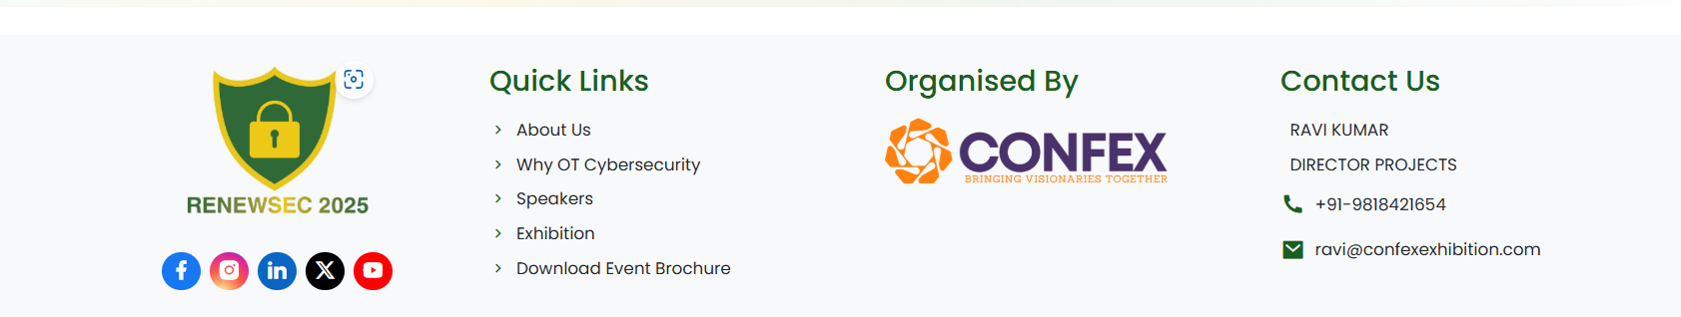

For this change the back ground and also bold the font



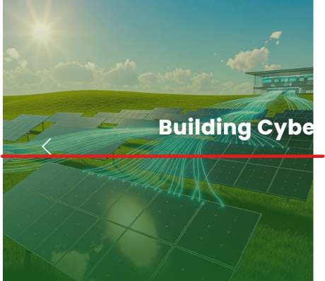Make the txext in that place where both OT and Cybersecurity is visible in the back ground

also make them both in similar line

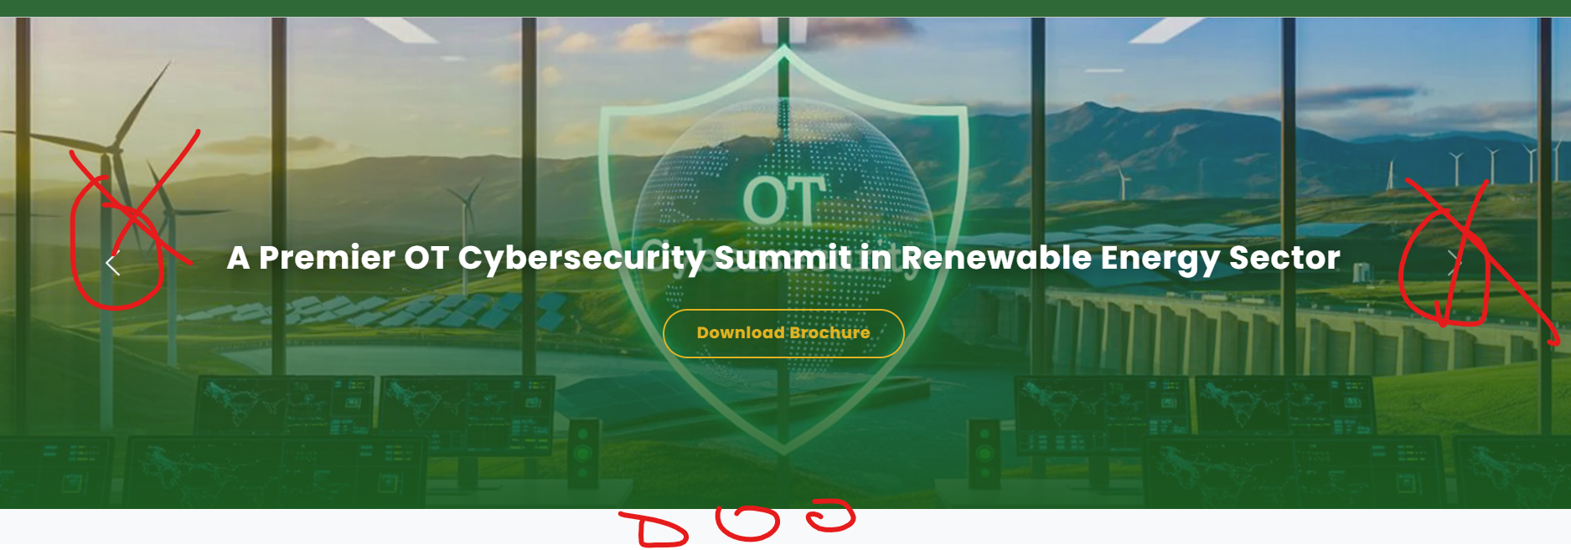

Remove these arrow and make circle



Make this ORGANI”S”ED .

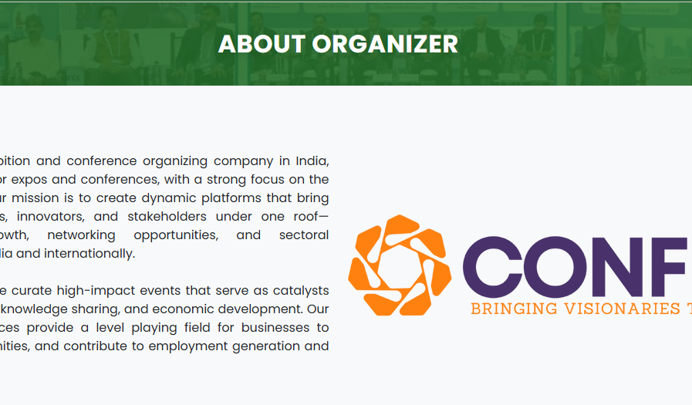

MAKE THIS SAME ORGANI”S”ED

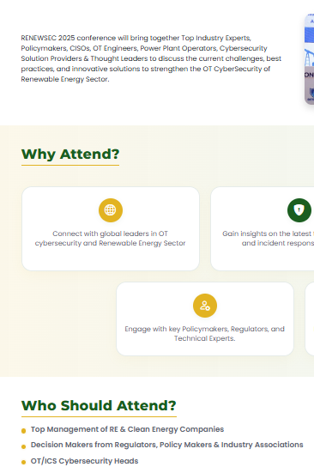

KEEP THE FONT FAMILY SAME

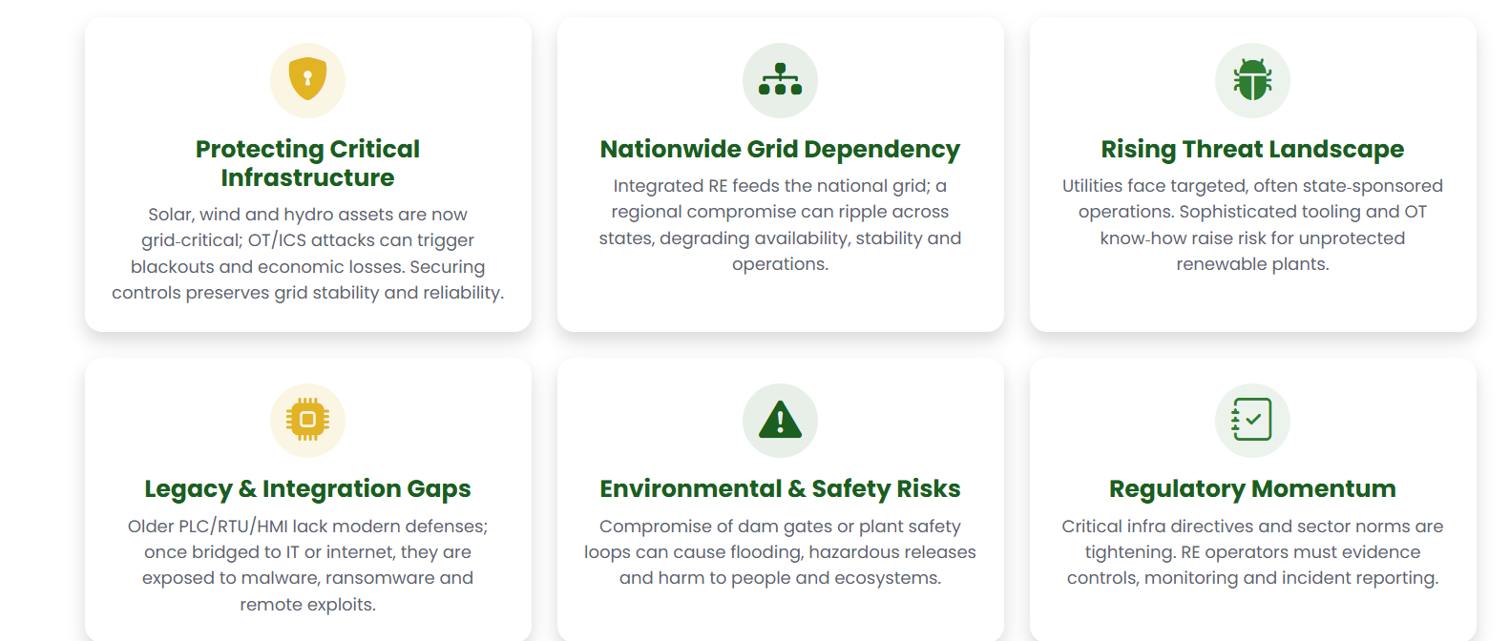HEADING IS OK BUT SUB CONTENT WILL BE CHANGED AS PER THE BROCHURE ALSO PASTING BELOW

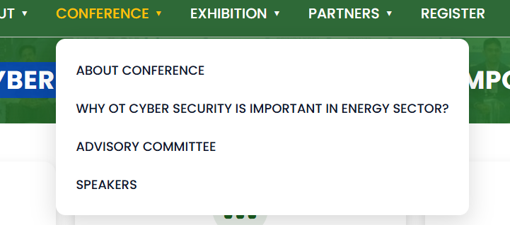

UPDATED THIS ALSO TO

“WHY OT CYBER SECURITY IS IMPORTANT IN RE SECTOR”

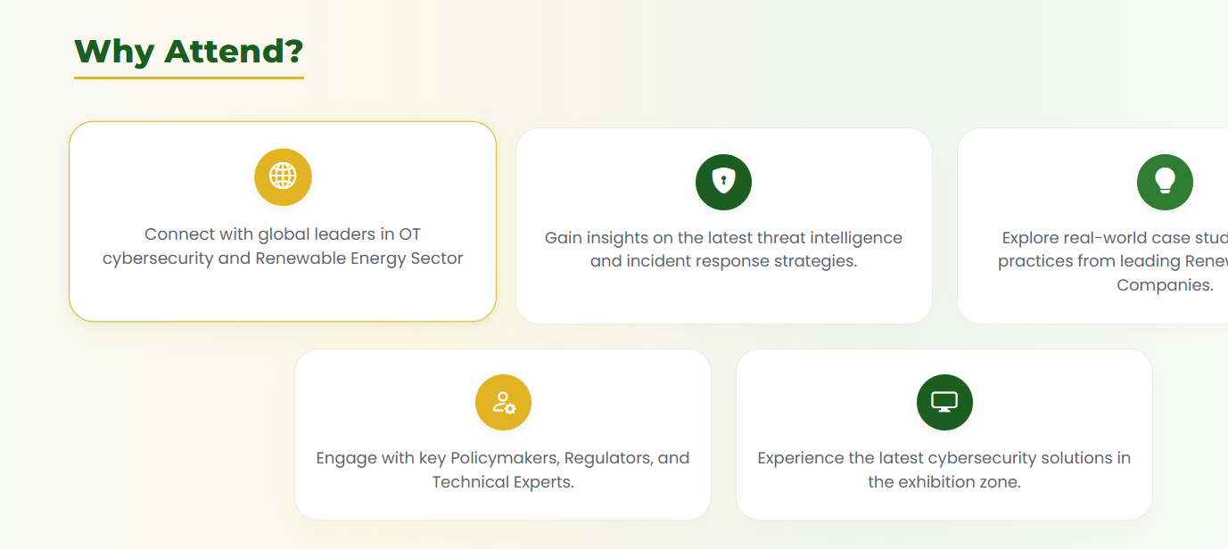

DO THIS DESIGNING THAT IS WE TOUCH THE BOX IT WILL FILL WITH SOME COLOR DO IT SAME FOR EVERY TAB WITH SOME CONTENT IN BOXES